

Physics Sample Examination Stage 2

Section 7 of the WACE Manual: 2008 – revised edition outlines the policy on WACE examinations.

Further information about the WACE Examinations policy can be accessed from the Curriculum Council website at
http://newwace.curriculum.wa.edu.au/pages/about_wace_manual.asp.

The purpose for providing a sample examination is to provide teachers with an example of how the course will be examined. Further finetuning will be made to this sample in 2007 by the examination panel following consultation with teachers, measurement specialists and advice from the Assessment, Review and Moderation (ARM) panel.

2008/18610[v2]




Western Australian Certificate of Education, Draft Sample External Examination

Question/Answer Booklet

Physics
Written paper
Please place your student identification label in this box
Stage 2

Student Number: In figures

In words

Time allowed for this paper
Reading time before commencing work: Ten minutes
Working time for paper: Three hours

Material required/recommended for this paper

To be provided by the supervisor
This Question/answer booklet; Formulae and constants sheet

To be provided by the candidate
Standard items: pens, pencils, eraser or correction fluid, ruler, highlighter

Special items: calculator

Important note to candidates
No other items may be taken into the examination room. It is your responsibility to ensure that you do not have any unauthorised notes or other items of a non-personal nature in the examination room. If you have any unauthorised material with you, hand it to the supervisor before reading any further.

All calculations are to be set out in detail. Marks may be awarded for correct equations and clear setting out, even if you cannot complete the calculation. Express numerical answers to two (2) or three (3) significant figures and include units where appropriate. Express estimates to one (1) or two (2) significant figures with units, and state any assumptions clearly.
Structure of this paper

Section of exam | Suggested working time | Number of questions | Number of questions to be attempted | Marks available
Section One | 70 minutes | 19 | all | 51
Section Two | 80 minutes | 6 | all | 55
Section Three | 30 minutes | 1 | all | 14
overall |  |  |  | 2
 |  |  | [Total marks] | 122
Note: the ‘overall’ section represents marks allocated to appropriate use of units and significant digits in final answers to numerical problems.

Instructions to candidates

1. The rules for the conduct of WACE examinations are detailed in the Student Information Handbook. Sitting this examination implies that you agree to abide by these rules.

2. Answer all questions in the spaces provided in this Question/Answer Booklet.

3. A blue or black ballpoint or ink pen should be used.
Section one: Short answer 51 marks

This section has nineteen (19) questions. Answer in the spaces provided.

Suggested working time: 70 minutes.

Question 1
- Explain briefly how the kinetic theory of matter distinguishes between heat and temperature.
[2 marks]

- Consider a 2 kg iron block and a 2 kg block of aluminium that are both at 20 °C. If you put 1000 J of heat into each of the blocks, will their temperatures still be equal? Explain.
[3 marks]
Circle the best answer: Yes No Insufficient data supplied
Explanation:

Question 2
If you drop a 2.00 kg house brick from the edge of a roof, 4.50 m high, with what kinetic energy will the brick impact the ground? Show your working clearly.
[3 marks]

Question 3
One light year is the distance that light, moving at 3.00 x 10⁸ m s⁻¹, travels in one year. Express one light year in metres.
[2 marks]

Question 4
If there are two or more light globes in a room, they are always connected in parallel. Give two reasons for this.
[2 marks]
Reason 1:

Reason 2:

Question 5
Show in a diagram how to connect a group of 1.00 Ω resistors so that the overall resistance of the group is 3.00 Ω.
[1 mark]

Question 6
When a neutron, 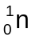, strikes an atom of 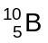, the products are alpha radiation, 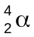, and an isotope of lithium, 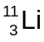. Write a balanced equation for this reaction.
[1 mark]

Question 7
Annette set up two resistors as shown in the diagram.
4.00 Ω
2.00 Ω
A
B

Annette used a multimeter to measure the resistance between A and B. Calculate the resistance value that was shown on the multimeter.
[3 marks]

Question 8
The half-life of 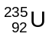 is 7.0 x 10⁸ years. Most geologists agree that the age of the Earth is about 5 x 10⁹ years. Calculate how many half lives of there have been since the Earth formed. (Round your answer to one significant digit.)
[2 marks]

Question 9
Lewis turned on a Geiger counter at a distance of 2.00 m from a source of beta radiation. As he carried the counter toward the radioactive source, the reading on the counter increased. Give two reasons why the measured activity of a beta source increases as the observer approaches the source.
[2 marks]
Reason 1:

Reason 2:

Question 10
A sample of potassium contains enough of the radioactive isotope 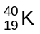 to emit radiation with a total energy of 1.00 x 10⁻⁹ J each second. This isotope has a long half-life, so its energy output does not change significantly over one year.

- Calculate the total energy the sample radiates over a one year period.
[1 mark]

- If this energy is absorbed by a 75.0 kg person, calculate their whole-body absorbed radiation dose, in gray, over one year.
(If you could not get an answer to part (a), use the value 5.00 x 10⁻³ J.)
[2 marks]

Question 11
- Name and define the unit of electrical potential difference (voltage).
[2 marks]

- An electric circuit consists of a battery connected to a light globe. It takes 15.0 joules of work to shift 2.50 coulombs of charge through the globe. What must be the emf (voltage) of the battery?
[2 marks]

Question 12
There are several different types of thermal insulation material for the home.

- One type of thermal insulation is a sheet of flexible plastic material covered on both sides by a silver, metallic coating. Explain how this could act as an insulator.
[2 marks]

- Another type of thermal insulation is a rectangular block of tangled glass fibres. Explain how this block could act as an insulator.
[2 marks]

Question 13
- Calculate the minimum amount of energy required to completely melt a 360 g block of ice that is at a temperature of 0 °C. The specific latent heat capacity of ice is 3.34 x 10⁵ J kg⁻¹.
[3 marks]

- Does this energy have to be transferred into the ice, or out of it, for the ice to melt?
[1 mark]
Circle the correct answer: Into Out of

Question 14
Jan put a hot piece of toast on a cool, dry plate and then lifted it off. She saw drops of water on the plate in the area that had been covered by the toast. Jan thought that the water came from moisture, evaporated from the toast, which had condensed on the plate.

Which one of the following would help Jan by supporting or rejecting her hypothesis? Only one answer is correct.
[1 mark]

- Measuring the temperature of the plate before and after the toast was on it.

- Weighing the toast before and after it was on the plate.

- Measuring the temperature of the toast before and after it was on the plate.

- Weighing the plate before and after the toast was on it.

Answer: _______

Question 15
Efficient electric water heaters have the heating element at the bottom of the hot water tank. Explain the advantage of this location, in terms of the transfer of energy from the element to the water.
[2 marks]
Heating element
Hot water
Water tank

Question 16
Complete the statements below:
- If a resistor is added to a circuit in parallel with the other resistors, the total resistance will:
[1 mark]
Circle the correct answer: Increase Decrease Remain the same

- If a resistor is added to a circuit in series with the other resistors, the total resistance will:
[1 mark]
Circle the correct answer: Increase Decrease Remain the same

- A fuse will ‘blow’ if which quantity becomes too great?
[1 mark]
Circle the correct answer: Resistance Potential difference Current

- If the potential difference across an ohmic conductor is increased, the current will:
[1 mark]
Circle the correct answer: Increase Decrease Remain the same

- If the potential difference across an ohmic conductor is increased, the resistance will:
[1 mark]
Circle the correct answer: Increase Decrease Remain the same

Question 17
Sam pushed a heavy crate from rest across a smooth (low friction) floor. The graph below shows how the force that Sam applied to the crate changed over time.
Force (N)
Time (s)
100
0
A
B
C
D

- Between which points was the acceleration of the crate greatest?
[1 mark]
Circle the correct answer: AB BC CD
Explain your answer:

[1 mark]
- Did Sam transfer any energy to the crate as he pushed it?
[1 mark]
Circle the correct answer: Yes No
Explain your answer:

[1 mark]
Question 18
One type of nuclear reactor, known as a breeder reactor, can potentially produce more nuclear fuel than it uses. In a breeder reactor, the isotope uranium-238, 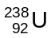 is converted to the isotope plutonium-239, 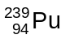. The advantage of this is that can undergo fission while cannot. The reaction occurs when absorbs a neutron. Two other particles are produced in this reaction.

Complete and balance the following nuclear equation showing the transformation of into as described above:
[2 marks]

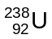 ____ 2 ____

Question 19
The graph below shows how the volume of 1.000 g of water changes as the temperature changes.
0.998
1.000
1.002
1.004
1.006
1.008
1.010
1.012
273
277
281
283
287
291
Volume (cm³)
Temperature (K)

The density of a substance is calculated as 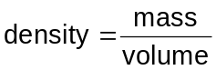. Considering the graph above, at which of the following temperatures is the density of water the greatest?
[1 mark]
A 273 K

B 275 K

C 277 K

D 290 K

Answer: _______

END OF SECTION ONE
Section two: Problem-solving 55 marks

This section has six (6) questions. Answer in the spaces provided.

Suggested working time: 80 minutes.

Question 20
Geraldine threw a 2.20 kg house brick vertically upwards at an initial speed of 3.20 m s⁻¹. She caught the brick as it fell back down. Ignore air resistance in this problem.

- Calculate the maximum height, above Geraldine’s hand, to which the brick rose.
[4 marks]

- The brick’s final velocity was its velocity at the instant that it reached Geraldine’s hand again on its downward flight. Determine the brick’s final velocity and justify your answer.
[2 marks]

- Explain what is meant by ’momentum’.
[1 mark]

- Calculate the brick’s momentum at the instant that it left Geraldine’s hand.
[4 marks]

Question 21
Max measured 2.00 kg of cold water into an insulated container of negligible heat capacity. Then, Max heated the water using an electrical immersion heater that drew 4.20 A of current from the 250 V supply.
Immersion heater
2.00 kg water
Insulated container
4.20 A, 250 V

- Calculate the power output, in watts, of the immersion heater.
[2 marks]

- Use your answer to part (a) to calculate the amount of energy, in joules, transferred from the heater to the water in a 10.0 minute interval.
(If you could not get an answer to part (a), use the value 1.00 x 10³ W.)
[4 marks]

- Use your answer to part (b) to show that the temperature rise of the water in this 10.0 minute interval is more than 70 °C.
(If you could not get an answer to part (b), use the value 6.00 x 10⁵ J.)
[3 marks]

Question 22
The graph below shows the velocity of a car, moving in a straight line, as a function of time.

Time (seconds)
2
4
6
8
10
12
14
16
18
4
8
12
16
20
Velocity (m s⁻¹)
0

- What was the car’s velocity at a time of 5.00 seconds after it began to move?
[1 mark]

- The car’s acceleration is shown by the gradient (slope) of the graph line. What was the car’s acceleration at a time of 3.00 seconds? Show your reasoning.
[3 marks]

- The car’s displacement is shown by the area under the graph line. What is the car’s displacement at a time of 8.00 seconds? Show your reasoning.
[3 marks]

- Was the car travelling backwards at a time of 10.0 seconds after it began to move?
[1 mark]
Circle the correct answer: Yes No
Question 23
Phosphorus-32, 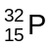, is a radioactive isotope that decays according to the equation:
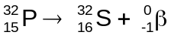
The nuclear masses of the reactant and the product, and the mass of the beta particle, are given in the table below, in unified atomic mass units.

Particle species | Mass (u)
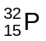 | 31.973 907
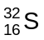 | 31.972 071
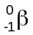 | 0.000 549

- There are 1.03 x 10¹⁵ decays per second in a 1.00 mg sample of . Express the activity of this sample in becquerel.
[1 mark]

- Explain:
  - mass defect
[1 mark]

  - binding energy
[1 mark]

  - the connection between mass defect and binding energy.
[3 marks]

- Show that energy must be given off when a nucleus decays.
[4 marks]

Question 24
lift
Winching motor
lift cable
ground floor
top floor
A passenger lift of total mass 2.00 x 10³ kg moves between the ground floor and the top floor.

At the moment shown in the diagram, the lift is moving downwards at a constant speed of 6.00 m s⁻¹.

The lift continues at this speed, then decelerates and
stops at ground level.

- What is the weight of the lift, in newtons, while it is moving downwards at a constant speed of 6.00 m s⁻¹? Show your reasoning.
[2 marks]

- What is the tension (force) in the lift cable when the lift moves downwards at constant speed?
[1 mark]

- Use labelled arrows on the diagram below to indicate the sizes and directions of all the forces acting on the lift when it is travelling downwards at a steady speed of 6.00 m s⁻¹:
[3 marks]

Question 25
Bridgette says, 'A light globe filament is hot when it is working normally, and cold when it is not working normally. The resistance of a light globe filament when it is operating is about ten times as great as when it is cold.’

Consider a light globe that is designed to operate at 60.0 watts on 240 volts.

- Calculate the resistance of the light globe filament when it is working normally.
[3 marks]

- If Bridgette’s statement is correct, what is the resistance of the light globe filament at the instant of switching on i.e. when it is cold?
(If you could not calculate a value in part (a), use 10.0 Ω.)
[1 mark]

- Explain the difference between an ohmic conductor and a non-ohmic conductor.
[2 marks]

- According to Bridgette, is a light globe filament an ohmic conductor?
[1 mark]
Circle the correct answer: Yes No

- You decide to measure the resistance of a light globe to determine whether Bridgette is correct. How would you measure the resistance when the light globe is operating? Sketch the electric circuit you would use.
[4 marks]

THIS PAGE HAS BEEN LEFT BLANK INTENTIONALLY
Section three: Comprehension 14 marks

This section has one (1) question. Answer in the spaces provided.

Suggested working time: 30 minutes.

Question 26
A group of engineering students decided to investigate the problems of high speed and stopping distances after a series of road accidents near their university.

They investigated stopping distances required by twenty drivers, each driving one of four 2004-model identical cars on a dry road in normal daylight. The drivers were required to respond to a visual signal, simulating a child running in front of the car. Electronic recorders registered the distance travelled by the car between the time that the signal was triggered and the instant that the driver applied the brakes. This was recorded as the ‘thinking distance’. The recorders then registered the distance travelled by the car while the brakes were applied. This was recorded as the ‘braking distance’.

The following table shows their results:

Trial number | Initial  speed,  km h^{–1} | Initial  speed,  m s^{–1} | Average  thinking  distance, m | Average  braking  distance, m | Average total  stopping  distance, m
1 | 30.0 | 8.33 | 6.00 | 6.00 | 12.0
2 | 45.0 | 12.5 | 9.00 | 14.0 | 23.0
3 | 60.0 | 16.7 | 12.0 | 24.0 | 36.0
4 | 75.0 | 20.8 | 18.0 | 38.0 | 55.0
5 | 90.0 | 25.0 | 17.0 | 55.0 | 73.0
6 | 105 | 29.2 | 21.0 | 75.0 | 96.0

- State one variable which the investigators decided to measure, and two variables that the investigators controlled to make their test fair.
[3 marks]
Measured variable:

One controlled variable:

Another controlled variable:

- Explain the following features of the experimental design in this investigation:
[2 marks]
(i) The investigators decided that each driver should perform each trial five times.

(ii) The investigators decided that each driver should perform the test at different speeds.

- Describe two ways in which the investigators have attempted to reduce errors in this experiment.
[2 marks]
One way:

Another way:

Question 26 (cont.)

The graph below shows the values of thinking distance plotted against initial speed.
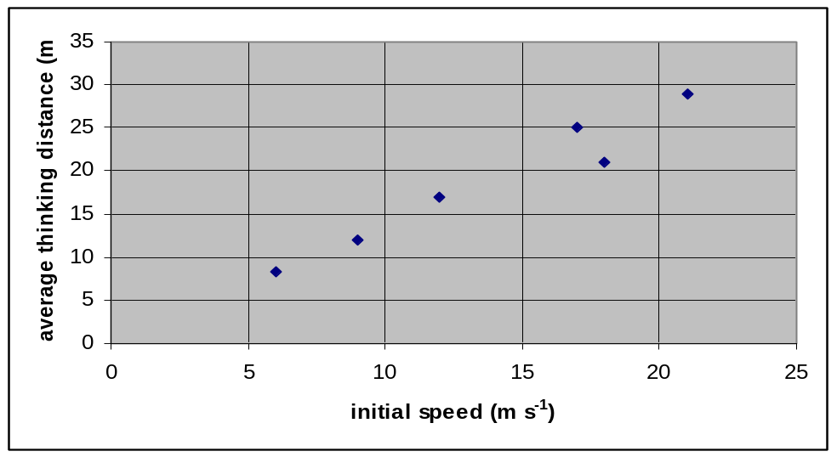

- (i) Draw a line of best fit (by eye) for the data shown in the graph.
[1 mark]
(ii) Describe the relationship between initial speed and thinking distance.
[1 mark]

(iii) Use the graph to determine an average value for the ‘thinking distance’ required by a driver travelling at 15.0 m s⁻¹. Show clearly how you worked out the distance from the graph.
[2 marks]

- Write a conclusion for this experiment on the basis of the data gathered by the experimenters.
[3 marks]

END OF PAPER
This blank space has been provided for additional workings.

This blank space has been provided for additional workings

Published by the Curriculum Council of Western Australia
27 Walters Drive
OSBORNE PARK WA 6017

